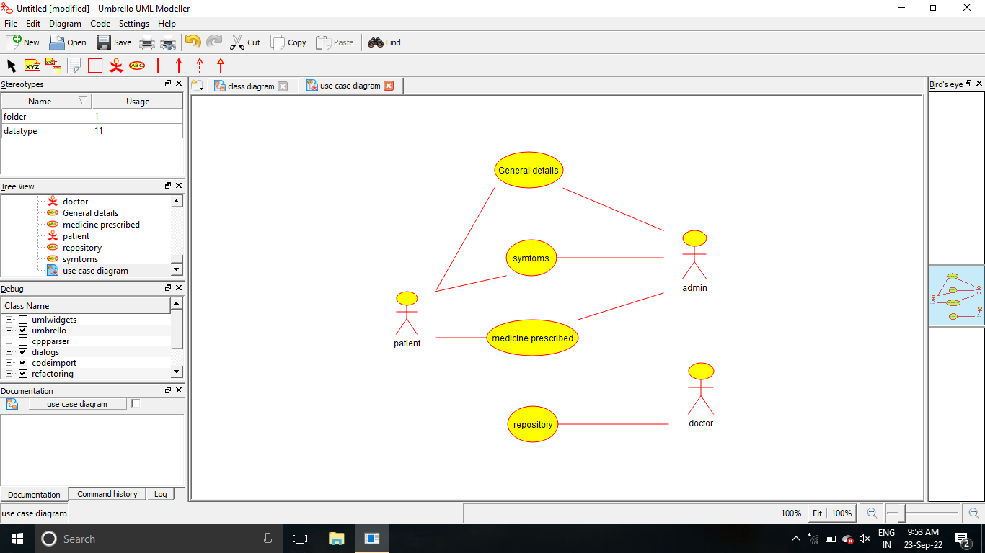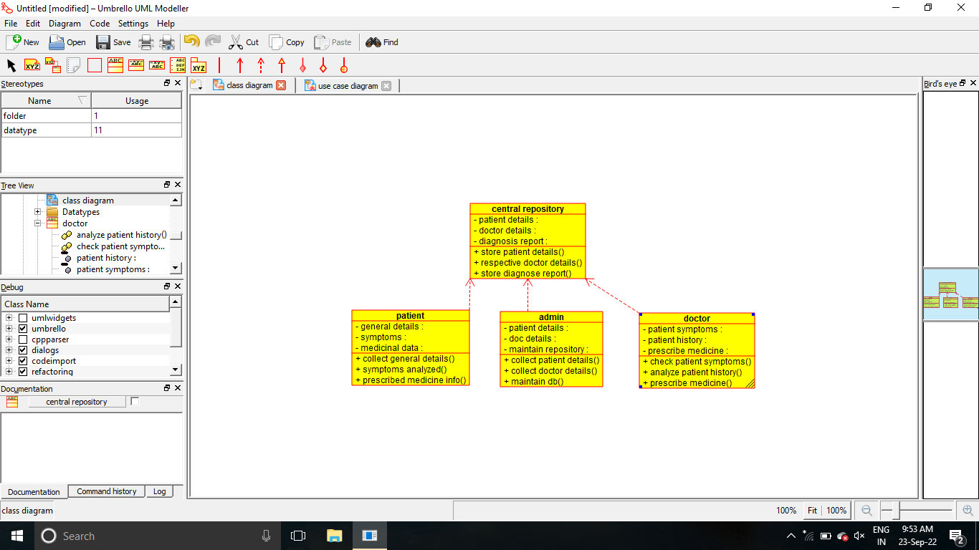

/**

 * Class admin

 */

public class admin {

  //

  // Fields

  //

  private void patient_details;

  private void doc_details;

  private void maintain_repository;

  //

  // Constructors

  //

  public admin () { };

  //

  // Methods

  //

  //

  // Accessor methods

  //

  /**

   * Set the value of patient_details

   * @param newVar the new value of patient_details

   */

  private void setPatient_details (void newVar) {

    patient_details = newVar;

  }

  /**

   * Get the value of patient_details

   * @return the value of patient_details

   */

  private void getPatient_details () {

    return patient_details;

  }

  /**

   * Set the value of doc_details

   * @param newVar the new value of doc_details

   */

  private void setDoc_details (void newVar) {

    doc_details = newVar;

  }

  /**

   * Get the value of doc_details

   * @return the value of doc_details

   */

  private void getDoc_details () {

    return doc_details;

  }

  /**

   * Set the value of maintain_repository

   * @param newVar the new value of maintain_repository

   */

  private void setMaintain_repository (void newVar) {

    maintain_repository = newVar;

  }

  /**

   * Get the value of maintain_repository

   * @return the value of maintain_repository

   */

  private void getMaintain_repository () {

    return maintain_repository;

  }

  //

  // Other methods

  //

  /**

   */

  public void collect_patient_details()

  {

  }

  /**

   */

  public void collect_doctor_details()

  {

  }

  /**

   */

  public void maintain_db()

  {

  }

}

/**

 * Class doctor

 */

public class doctor {

  //

  // Fields

  //

  private void patient_symptoms;

  private void patient_history;

  private void prescribe_medicine;

  //

  // Constructors

  //

  public doctor () { };

  //

  // Methods

  //

  //

  // Accessor methods

  //

  /**

   * Set the value of patient_symptoms

   * @param newVar the new value of patient_symptoms

   */

  private void setPatient_symptoms (void newVar) {

    patient_symptoms = newVar;

  }

  /**

   * Get the value of patient_symptoms

   * @return the value of patient_symptoms

   */

  private void getPatient_symptoms () {

    return patient_symptoms;

  }

  /**

   * Set the value of patient_history

   * @param newVar the new value of patient_history

   */

  private void setPatient_history (void newVar) {

    patient_history = newVar;

  }

  /**

   * Get the value of patient_history

   * @return the value of patient_history

   */

  private void getPatient_history () {

    return patient_history;

  }

  /**

   * Set the value of prescribe_medicine

   * @param newVar the new value of prescribe_medicine

   */

  private void setPrescribe_medicine (void newVar) {

    prescribe_medicine = newVar;

  }

  /**

   * Get the value of prescribe_medicine

   * @return the value of prescribe_medicine

   */

  private void getPrescribe_medicine () {

    return prescribe_medicine;

  }

  //

  // Other methods

  //

  /**

   */

  public void check_patient_symptoms()

  {

  }

  /**

   */

  public void analyze_patient_history()

  {

  }

  /**

   */

  public void prescribe_medicine()

  {

  }

}

/**

 * Class patient

 */

public class patient {

  //

  // Fields

  //

  private void general_details;

  private void symptoms;

  private void medicinal_data;

  //

  // Constructors

  //

  public patient () { };

  //

  // Methods

  //

  //

  // Accessor methods

  //

  /**

   * Set the value of general_details

   * @param newVar the new value of general_details

   */

  private void setGeneral_details (void newVar) {

    general_details = newVar;

  }

  /**

   * Get the value of general_details

   * @return the value of general_details

   */

  private void getGeneral_details () {

    return general_details;

  }

  /**

   * Set the value of symptoms

   * @param newVar the new value of symptoms

   */

  private void setSymptoms (void newVar) {

    symptoms = newVar;

  }

  /**

   * Get the value of symptoms

   * @return the value of symptoms

   */

  private void getSymptoms () {

    return symptoms;

  }

  /**

   * Set the value of medicinal_data

   * @param newVar the new value of medicinal_data

   */

  private void setMedicinal_data (void newVar) {

    medicinal_data = newVar;

  }

  /**

   * Get the value of medicinal_data

   * @return the value of medicinal_data

   */

  private void getMedicinal_data () {

    return medicinal_data;

  }

  //

  // Other methods

  //

  /**

   */

  public void collect_general_details()

  {

  }

  /**

   */

  public void symptoms_analyzed()

  {

  }

  /**

   */

  public void prescribed_medicine_info()

  {

  }

}